Your Name
Supervisor Name
Course Name
Due Date

Title of Your Paper
The main text in an MLA formatted paper is left-aligned. Don’t use the right-side justification, since that is not in line with the guidelines of the ninth edition MLA Handbook, published in 2021. Text is also double-spaced throughout your paper—not only the body text, but also headings, titles, and the entries in the Works Cited list.
The first sentence of every new paragraph in your essay is indented half an inch (1.27 cm). This makes it easier for your reader to see the transitions between paragraphs. In this template, we have automated the indent by dragging the square block in the ruler to the half-inch mark. When you move the square in the ruler, you will see that the indent of the paragraph changes. If you select all the text in this document and then move the square block, the indent will change for all paragraphs.
In longer papers you might want to use headings to help organize and provide structure to your paper. There are no formatting requirements set by MLA—the only rules are that you must be consistent, use title-case capitalization, and not add a period after the heading. We recommend keeping the font and size the same as the body text. In general, boldface indicates greater prominence, while italics are appropriate for subordinate headings.

Heading Example
After researching your topic, you might end up quoting or paraphrasing from other sources. It’s important that you do this correctly in order to avoid committing plagiarism. In MLA style, a proper citation consists of two parts: the in-text citation and the entry in the Works Cited list. The in-text citation is placed right after the quote or paraphrase and contains the author’s last name and page number. Usually this information is placed within parentheses. Let’s look at an example: “A membership referendum held today would be backed by 55 percent of Danish voters” (Levring 8).
In some situations, you might want to include a table or illustration in your paper. These should be placed as close to the relevant part of text as possible. Tables are usually labeled and numbered, along with a descriptive title. The label and title are placed above the table on separate lines. A reference to the source is placed in the caption immediately below the table, followed by any explanatory notes, are placed below the table and assigned a lowercase letter instead of a numeral.

Table 1
Percentage of EU Population Capable of Conversation in a Foreign Languageª
Age | One Language | Two Languages | Three languages
15–24 | 74% | 37% | 12%
25–39 | 64% | 31% | 12%
40–54 | 55% | 25% | 10%
55+ | 38% | 17% | 7%
Adapted from: Raimo Streefkerk. “MLA Format for Academic Papers and Essays.” Scribbr. 18 Jun. 2021, www.scribbr.com/mla/formatting/.
- Research based on 1,500 participants from 15 countries.

Illustrations (any images other than tables) are also labeled and numbered. The label “Figure” is abbreviated to “Fig.” and followed by a number and caption. This information is placed directly below the image, centered and ending with a period.

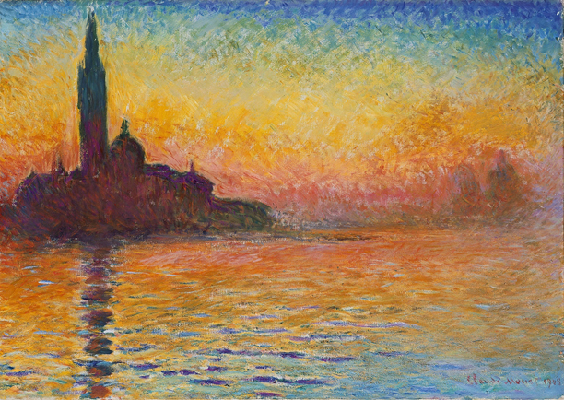
Fig. 1. Claude Monet, San Giorgio Maggiore at Dusk, 1908–1912.

The in-text citation we included in an earlier paragraph corresponds to an entry in the Works Cited list, placed at the end of your paper on a separate page. There you give more information about each source (e.g., the title, publisher, and date of publication). If a reference entry is longer than one line, each line after the first should be indented a half-inch (called a hanging indent). The entries in the list are then sorted alphabetically. You can either create the entries manually or use an accurate citation generator such as Scribbr’s MLA Citation Generator.

Works Cited
Adams, Amanda. Citing Sources: How to Cite a Book. Academic Press, 2019.
Barnes, Barney. “A Chapter in an Edited Collection.” A Book of Examples, edited by John Smith, Academic Press, 2019, pp. 25–35.
Cox, Christopher, and Brian D. Smith. “The Title of the Article.” Website Name, 15 Sept. 2019, www.scribbr.com/page.
Dayton, Daniels, and Bob Matthew Williams. “Journal Article Title.” Journal of Academic Research, vol. 32, no. 15, 2014, pp. 232–265, https://doi.org/10.1080/02626667.2018.1560449.
Fox, Ferdinant, et al. The Basics of Citing in MLA Style. 2nd ed., Scribbr Press, 2008.

How to Easily Create MLA Citations
Create your own MLA style citations with the free Scribbr MLA Citation Generator. It’s the easiest and most reliable tool for creating and managing your MLA Works Cited list and in-text citations, based on the most recent 9th edition MLA format requirements.

